**Mr. Visca’s: Calculus (Chpt 4.2)**

**Chpt 4 – Day 2: Mean Value Theorem**

**4.2 Mean Value Theorem**

When does a function increase or decrease? Example:

When *f* ' (x) > 0 *f* is ______________________. Find any minima or maxima for *f* (x) = x3 - 4x.

When *f* ' (x) < 0 *f* is ______________________.

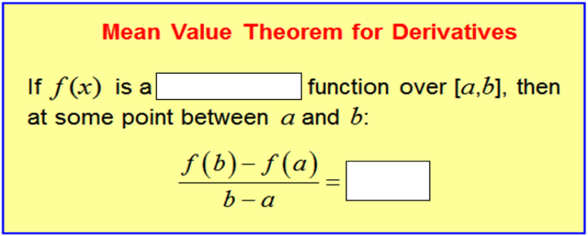

Example: Show that the function *f* (*x*) = x2 satisfies the hypothesis of the mean value theorem on the interval [0,2]. Then find a solution to the equation.

Example: Explain the following function fails to satisfy the conditions of the mean value theorem for the interval

[-1,1].



Example: A car traveled 310 miles in 5 hours. Show that the car must have been going 60 mph at some point during the trip.

Example: Find the function, f(x) whose derivative is sin(x) and whose graph passes through the point (0,2).

The process of finding the original function from the derivative is so important that it has a name:

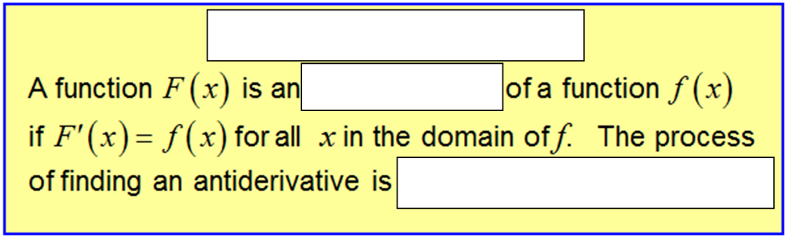

You will hear much more about antiderivatives in the future

This section is just an introduction.

Example: Assuming a body falls from rest, s(0) = 0, find the velocity and position equations for a downward acceleration of 9.8 m/sec2 and an initial velocity of 1 m/sec downward. (we are going to assume velocity to be positive 1 even though it's accelerating downward.)

*Section 4.2 (Page 202)*

*#s: 1, 3, 6, 9, 11-16, 19, 21, 25*